**Hardware**

**External view**

The [console](http://www.dummies.com/how-to/content/the-back-of-your-computer-console.html#glossary-console)’s backside is its busy side. On the back of a computer console, you find various connectors for the many other devices in your computer system: the console’s back also has a place to plug in the [monitor](http://www.dummies.com/how-to/content/the-back-of-your-computer-console.html#glossary-monitor), [keyboard](http://www.dummies.com/how-to/content/the-back-of-your-computer-console.html#glossary-keyboard), [mouse](http://www.dummies.com/how-to/content/the-back-of-your-computer-console.html#glossary-mouse), [speakers](http://www.dummies.com/how-to/content/the-back-of-your-computer-console.html#glossary-speakers), and just about anything else that came in the box with the PC.

Use this figure as a guide for finding the following important items on the back of your PC’s console:

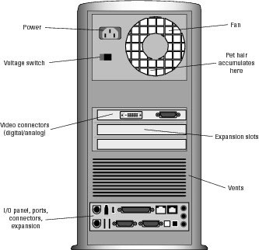

* **Power:** This thing is where the PC plugs into a cord that plugs into the wall.
* **Fan:** Air gets sucked in here, blows around inside the console to keep things cool, and then puffs out the vents.
* **Voltage** [**switch**](http://www.dummies.com/how-to/content/the-back-of-your-computer-console.html#glossary-switch)**:** Use this item to switch power frequencies to match the specifications for your country, region, or planet.
* **Expansion** [**slots**](http://www.dummies.com/how-to/content/the-back-of-your-computer-console.html#glossary-expansion_slot)**:** These slots are available for adding new components to the console and expanding your PC’s hardware.
* **Vents:** The breathing thing again.
* **I/O panel:** Aside from the power cord, and anything attached to an [expansion](http://www.dummies.com/how-to/content/the-back-of-your-computer-console.html#glossary-expansion_card) [card](http://www.dummies.com/how-to/content/the-back-of-your-computer-console.html#glossary-expansion_card), the rest of your PC’s expansion options and plug-in-type things are located in a central area that I call the I/O panel.

**Internal view**

This is an internal view of a computer. It is made up of many separate parts.

[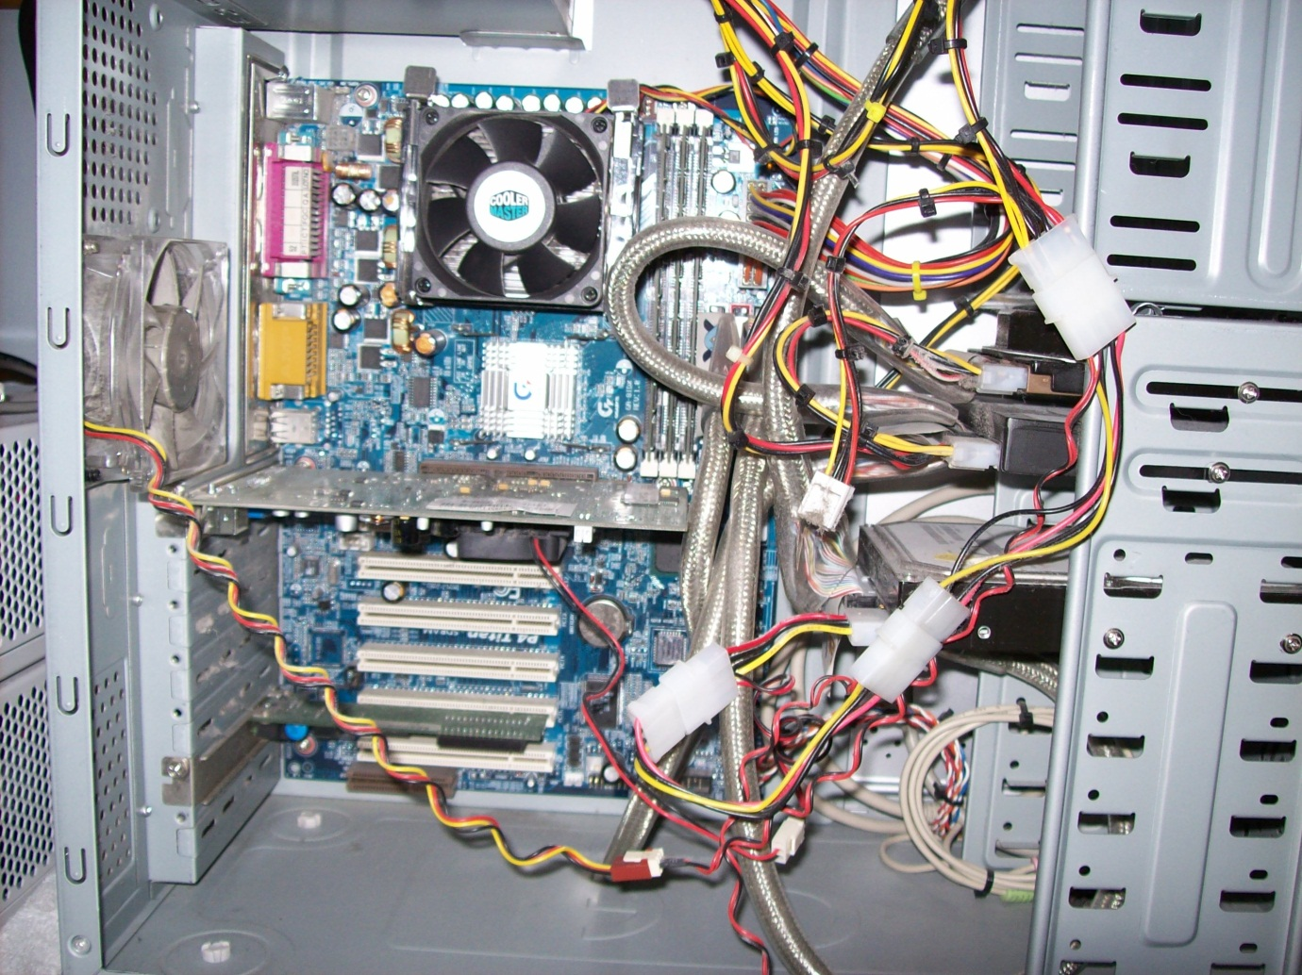](http://www.google.co.uk/url?sa=i&rct=j&q=internal+view+of+a+computer&source=images&cd=&cad=rja&docid=g_BNVSRyg0honM&tbnid=SpK4pmmqXMvGVM:&ved=0CAUQjRw&url=http://www.paul-boggia.me.uk/Hardware.htm&ei=ffn8UczuHomX1AXM8ICgAQ&psig=AFQjCNEJH-dV2BYbqCUJlfLE8dAuLQhfyw&ust=1375619765361782)

**Power Supply Unit (PSU)**

The PSU supplies power to all the components in the computer.

[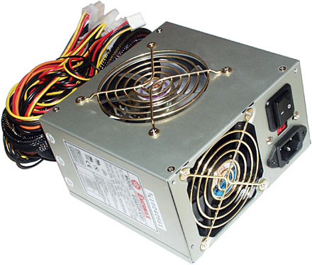](http://www.google.co.uk/url?sa=i&rct=j&q=PSU&source=images&cd=&cad=rja&docid=GRone1udS9YvKM&tbnid=e8kTP2aa9Aj7ZM:&ved=0CAUQjRw&url=http://www.dansdata.com/io006.htm&ei=rvn8UZivGOn20gXh7oHwBg&psig=AFQjCNFjWoY25ZgJDD9QrnhFjQJZa3l0kA&ust=1375619872396264)

**Motherboard**

A motherboard (sometimes alternatively known as the mainboard, system board, planar board or logic board,[1] or colloquially, a mobo) is the main printed circuit board (PCB) found in computers and other expandable systems. It holds many of the crucial electronic components of the system, such as the central processing unit (CPU) and memory, and provides connectors for other peripherals. Unlike a backplane, a motherboard contains significant sub-systems such as the processor.

Motherboard specifically refers to a PCB with expansion capability - the board is the "mother" of all components attached to it, which often include sound cards, video cards, network cards, hard drives or other forms of persistent storage, TV tuner cards, cards providing extra USB or Firewire slots, and a variety of other custom components. (The term mainboard is applied to devices with a single board and no additional expansions or capability, such as controlling boards in televisions, washing machines and other embedded systems.)

[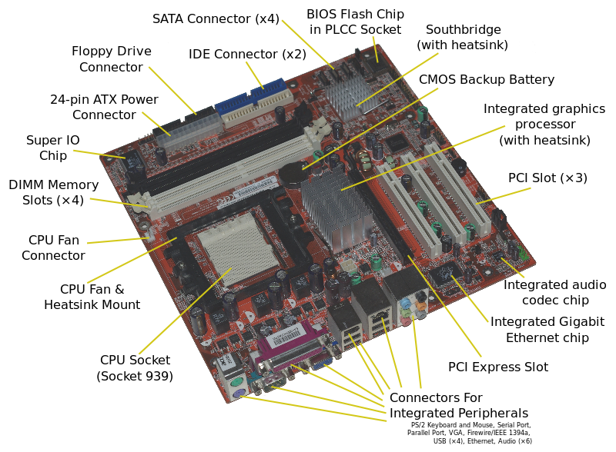](http://upload.wikimedia.org/wikipedia/commons/9/9d/Acer_E360_Socket_939_motherboard_by_Foxconn.svg)

**Random Access Memory**

Random-access memory (RAM) is a form of computer data storage. A random-access device allows stored data to be accessed directly in any random order. In contrast, other data storage media such as hard disks, CDs, DVDs and magnetic tape, as well as early primary memory types such as drum memory, read and write data only in a predetermined order, consecutively, because of mechanical design limitations. Therefore the time to access a given data location varies significantly depending on its physical location.

Today, random-access memory takes the form of integrated circuits. Strictly speaking, modern types of DRAM are not random access, as data is read in bursts, although the name DRAM / RAM has stuck. However, many types of SRAM, ROM, OTP, and NOR flash are still random access even in a strict sense. RAM is normally associated with volatile types of memory (such as DRAM memory modules), where its stored information is lost if the power is removed. Many other types of non-volatile memory are RAM as well, including most types of ROM and a type of flash memory called NOR-Flash.

[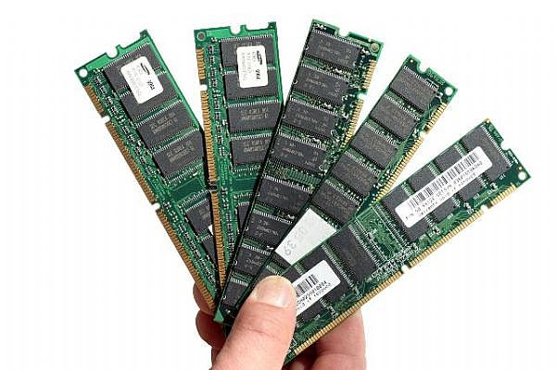](http://www.google.co.uk/url?sa=i&rct=j&q=ram&source=images&cd=&cad=rja&docid=RJC0jz3YK0LnhM&tbnid=RNFxxrO-zNZLfM:&ved=0CAUQjRw&url=http://www.imacland.com/Additional-Mac-Ram-Puts-More-Speed.html&ei=7fn8Uf77K4X40gXYy4HwDQ&psig=AFQjCNG1G2jFHT4ABrYofW5Fkf5k154f-A&ust=1375619938810137)

**CMOS Battery**

The battery is located on the motherboard, it powers a chip called the Real Time Clock (RTC) chip and ensures the system time and BIOS settings do not revert to default values.

[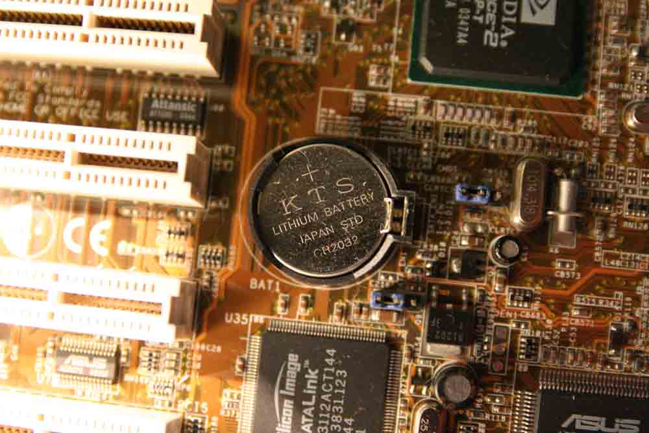](http://www.google.co.uk/url?sa=i&rct=j&q=computer+battery&source=images&cd=&cad=rja&docid=AApS5QOc_lquKM&tbnid=WzCqVdj26xvDiM:&ved=0CAUQjRw&url=http://www.build-my-home-computer.com/motherboard-battery.html&ei=c_r8UbGaG8H60gWPhIGoCw&psig=AFQjCNEalXX67rcxTwDV3fDJ_ANOydLusw&ust=1375620075565733)

**Central Processing Unit (CPU)**

This is the brain of the computer!

A central processing unit (CPU), also referred to as a central processor unit,[1] is the hardware within a computer that carries out the instructions of a computer program by performing the basic arithmetical, logical, and input/output operations of the system.

A computer can have more than one CPU; this is called multiprocessing. Some integrated circuits (ICs) can contain multiple CPUs on a single chip; those ICs are called multi-core processors.

Two typical components of a CPU are the arithmetic logic unit (ALU), which performs arithmetic and logical operations, and the control unit (CU), which extracts instructions from memory and decodes and executes them, calling on the ALU when necessary.

[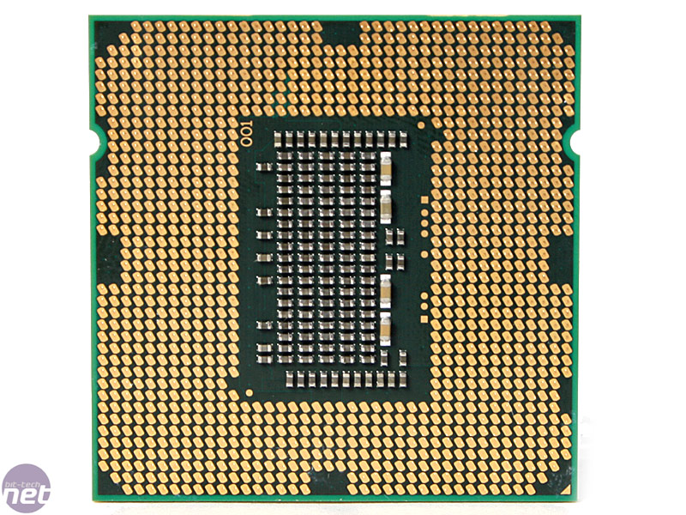](http://www.google.co.uk/url?sa=i&rct=j&q=CPU&source=images&cd=&cad=rja&docid=4QYLB3MuS-rTxM&tbnid=iFyGxiJQGrw3dM:&ved=0CAUQjRw&url=http://www.bit-tech.net/hardware/cpus/2009/09/08/intel-lynnfield-details-and-architecture/&ei=APv8UdCgD6Gh0QXZnYCIAg&psig=AFQjCNHGHU07tM8UVZvlDyZjKIY12qrSUw&ust=1375620204493375)

[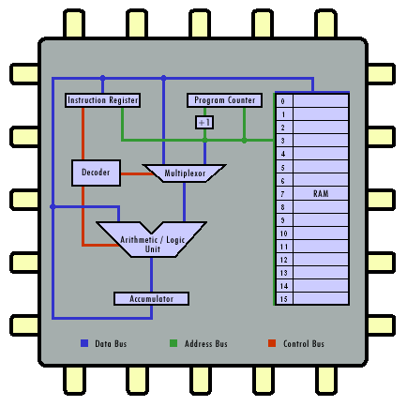](http://www.google.co.uk/url?sa=i&rct=j&q=CPU&source=images&cd=&cad=rja&docid=k_akuP1lLtDl-M&tbnid=QT0XFIpdgxlebM:&ved=0CAUQjRw&url=http://courses.cs.vt.edu/csonline/MachineArchitecture/Lessons/CPU/Lesson.html&ei=JPv8Uf-VKqmV0AWTuIHoCw&psig=AFQjCNHGHU07tM8UVZvlDyZjKIY12qrSUw&ust=1375620204493375)

**CPU Heatsink**

During processing the CPU gets very hot therefore The CPU needs a heat sink. The heatsink draws heat energy away from the CPU by dissipating the heat through its fins into the air. The fan draws the warm air away from the heatsink allowing a greater degree of heat exchange to occur.

The heatsink is joined to the CPU but metal on metal connection is inefficient. To increase the efficiency heat conductive paste is used. This Paste allows a for far greater heat conduction away from the CPU.

[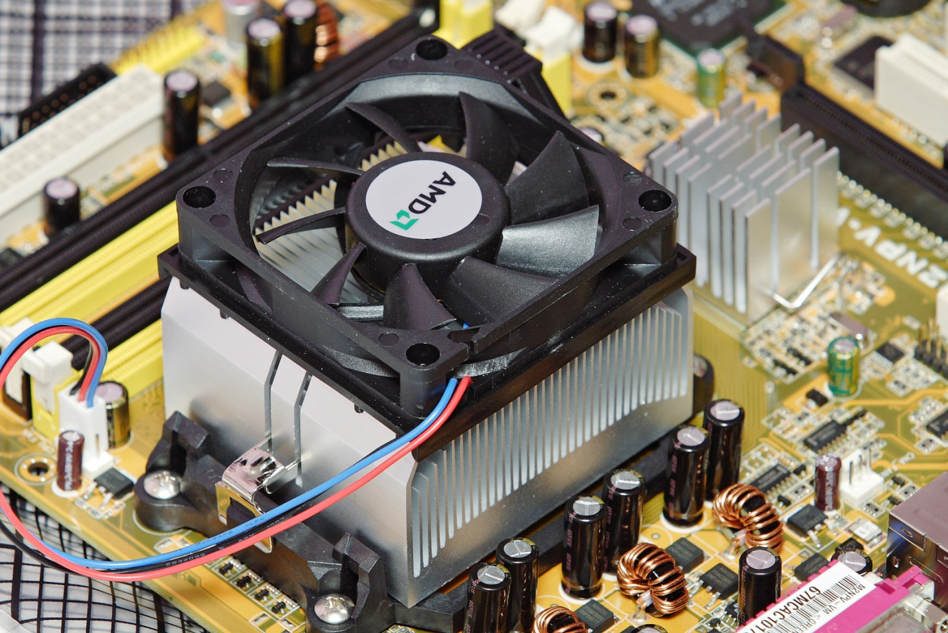](http://www.google.co.uk/url?sa=i&rct=j&q=CPU+heatsink&source=images&cd=&cad=rja&docid=QMrB7apK2oPw7M&tbnid=K5eXA7SZKZcgmM:&ved=0CAUQjRw&url=https://commons.wikimedia.org/wiki/File:AMD_heatsink_and_fan.jpg&ei=ZPz8UZWrCI2a1AXpm4GADw&psig=AFQjCNGgH_tl3WE_yD7cgGG3b5SqNx6xtg&ust=1375620553279281)

**Hard drive**

A hard disk drive (HDD)[note 2] is a data storage device used for storing and retrieving digital information using rapidly rotating disks (platters) coated with magnetic material. An HDD retains its data even when powered off. Data is read in a random-access manner, meaning individual blocks of data can be stored or retrieved in any order rather than sequentially. An HDD consists of one or more rigid ("hard") rapidly rotating disks (platters) with magnetic heads arranged on a moving actuator arm to read and write data to the surfaces.

[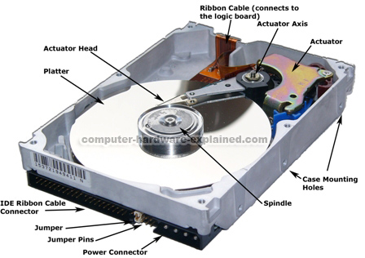](http://www.google.co.uk/url?sa=i&source=images&cd=&cad=rja&docid=rvW9m7qoq0YDgM&tbnid=eZpjdzVThMyqcM:&ved=0CAgQjRwwAA&url=http://www.computer-hardware-explained.com/computer-hard-drive.html&ei=Kvr8UenwNojxPJ7kgBA&psig=AFQjCNEFfWSIejdpeLK6I1ntLhXQm-GOnQ&ust=1375620010937615)

**Optical Disk / CD / DVD Drive**

In computing, an optical disc drive (ODD) is a disk drive that uses laser light or electromagnetic waves within or near the visible light spectrum as part of the process of reading or writing data to or from optical discs. Some drives can only read from discs, but recent drives are commonly both readers and recorders, also called burners or writers. Compact discs, DVDs, and Blu-ray discs are common types of optical media which can be read and recorded by such drives. Optical drive is the generic name; drives are usually described as "CD" "DVD", or "Blu-ray", followed by "drive", "writer", etc.

Optical disc drives are an integral part of stand-alone consumer appliances such as CD players, DVD players and DVD recorders. They are also very commonly used in computers to read software and consumer media distributed on disc, and to record discs for archival and data exchange purposes. Floppy disk drives, with capacity of 1.44 MB, have been made obsolete: optical media are cheap and have vastly higher capacity to handle the large files used since the days of floppy discs, and the vast majority of computers and much consumer entertainment hardware have optical writers. USB flash drives, high-capacity, small, and inexpensive, are suitable where read/write capability is required.

Disc recording is restricted to storing files playable on consumer appliances (films, music, etc.), relatively small volumes of data (e.g., a standard DVD holds 4.7 gigabytes) for local use, and data for distribution, but only on a small-scale; mass-producing large numbers of identical discs is cheaper and faster than individual recording.

Optical discs are used to back up relatively small volumes of data, but backing up of entire hard drives, typically containing many hundreds of gigabytes, is less practical than with the smaller capacities available previously.

[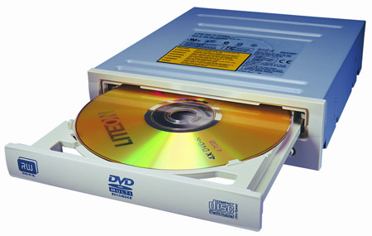](http://www.google.co.uk/url?sa=i&rct=j&q=cd+drive&source=images&cd=&cad=rja&docid=9EDyUH5v0DypQM&tbnid=r4J8SuUlDgM57M:&ved=0CAUQjRw&url=http://andystech.net/the-end-for-optical-drives/&ei=p_z8Ub3ZJobA0QW7woGYDw&psig=AFQjCNEapUYujQ-MFp7nd-zARpmeRas4Gg&ust=1375620634889564)